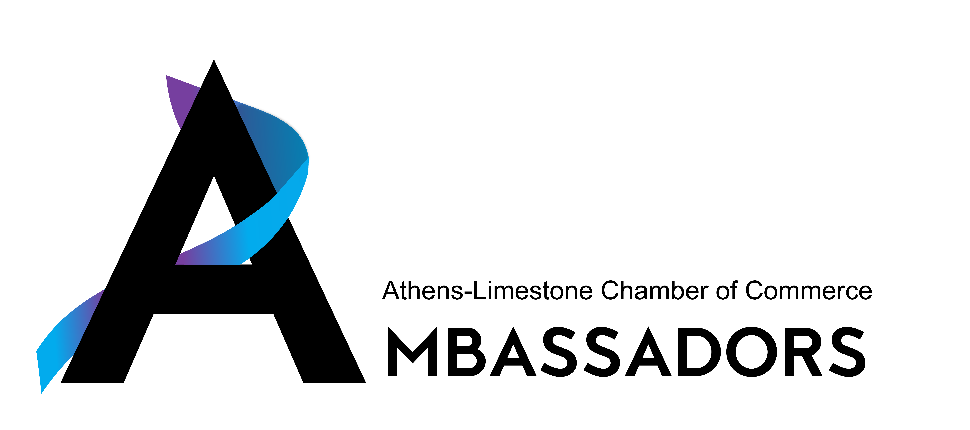

Athens Limestone Chamber Ambassador Qualifications and Responsibilities

Mission Statement

Striving to instill the positive aspects of our diverse business community to help promote member retention and continuous growth in our Chamber membership and community as a whole.

QUALIFICATIONS:

• Member of the Athens Limestone County Chamber of Commerce in good standing.
• Enthusiastic, professional and outgoing.
• Willing to make a commitment to the Ambassador program for a period of 12 months.
• Possesses leadership qualities and skills to promote Chamber programs and initiatives.

RESPONSIBILITIES:

• To support and actively participate in the goals and action plans set forth by the Chamber Board of Directors.
• To welcome and involve new members by encouraging participation in Chamber sponsored events.
• Attend ribbon cuttings, groundbreakings, relocations, and grand openings.
• Volunteer for at least 2 Chamber sponsored events such as Ole Time Fiddlers Convention, Christmas Open House, Sporting Clays Tournament, Home & Garden Show and other opportunities that arise during the year.
• Serve as a mentor to new chamber members. An important way to provide mentorship is at Chamber Coffee’s or other Chamber Events. It is vital that everyone is made to feel welcome. Please take the opportunity to welcome new members. Welcoming new members or those that attend an event for the first time will encourage participation in Chamber events.

• Ambassadors scheduled to attend events will be appropriately dressed and professionally groomed while representing the Chamber. Please present yourself as professionally as possible while representing the Athens Limestone Chamber of Commerce as an Ambassador.
• Active Ambassadors are asked to attend as many events as work allows. If there is a reason for an extended absence, we ask that you contact Debra Porter.

Please communicate directly with Pammie Jimmar, Chamber President, Debra Porter, Membership and Operations Director if questions or concerns arise.

